## Merchant

Demo date: Nov 20, 2024  
Scoping start date: Nov 20, 2024

MSA Signature Date: Nov 21, 2024  
Onboarding Kick Off Date: Nov 27, 2024

[If Exists] Opt Out Date: None  
Go Live Date: Jan 1, 2025

GTM POC: Ben  
Implementation POC: Jeff

ERP: QBO

Tax Integration: Other - Taxjar

### 

### Key people at Merchant

### COO - Greg Atkins

### Owners Brian and Steve

### 

| Notes Sections [Ops International Team to Ignore] *(AE/ Implementation to fill)*   * Info on how merchant bills   + Mostly Flat Saas Fee   + They have step ups, 1 time projects, and apps to bill for periodically   + May have a remittance use case * Is there any important merchant relationship information?  1) What is the merchant temperament? Great to work with, Greg is very engaged 2) Is there a key POC: (i.e.: who is the buyer/decision maker?) Greg handles the day to day 3) What are the Tabs features that the key POC cares about? Automation to support rapid growth |
| --- |

### 

### Company summary *(AE to fill)*

MidwayPlus is a digital business hub specializing in B2B and B2C eCommerce solutions. The company helps manufacturers, particularly in the aftermarket automotive parts industry, connect directly with resellers and consumers. By providing an integrated platform, MidwayPlus enables manufacturers to streamline operations, reduce reliance on traditional wholesale distribution, and expand sales channels. Resellers benefit from a simplified process that allows them to purchase from multiple manufacturers as easily as shopping on platforms like Amazon. They are able to connect buyers to new sellers.

The platform also offers advanced functionalities like ERP integration, real-time automation, and marketing tools, enabling businesses to manage their sales, logistics, and customer relationships seamlessly.

* ~2m in revenue today and facing hockey stick growth. Mostly invoicing manually out of QBO (and a little out of stripe).
* They are a marketplace with 15-20 active customers w/ 15-20 invoices / month. They have multiple revenue streams and items they bill for (step-ups, one-time projects, periodic app charges)
* Could be a remittance use case with some of their marketplace business involving them invoicing for a percentage based on sales
* Greg has been great to work with and is excited to have the kickoff meeting on Wednesday so he can work on setting up Tabs a bit over the holiday weekend in his free time

Goals (North star)  
*(AE/ Implementation to fill)*

What is the merchant's goal? What pain are we solving? Why are they buying Tabs?  
Current processes aren’t scalable - Have some collections challenges, Lack tools to effectively track outstanding payments and automate reminders, leading to potential cash flow disruptions

Is there an opt out clause? If so, what is the merchant looking for so they do not exercise it?  
No

### Billing model *(AE/ Implementation to fill)*

* Are there unique things about the customer creation process for this merchant?
* Information on how merchant bills

They are a marketplace with 15-20 active customers w/ 15-20 invoices / month. They bill these manually today. They have multiple revenue streams and items they bill for (step-ups, one-time projects, periodic app charges)

* How contract is broken up Most of what we have seen are flat fees with step ups and one time charges
* One off things to know about the merchant

We did speak about a potential remittance use case, but it was not part of the main scope of what we need to solve for initially. It may be worth discussing with the merchant however.

### Contract Processing Steps *(Implementation/Success to fill)*

1. Steps to process
   1. Customer creation
      1. All customers exist in QBO - should not be a need to create any customers
   2. Services Start Date & Invoice Start Date found in *Date*: in top right corner of contract

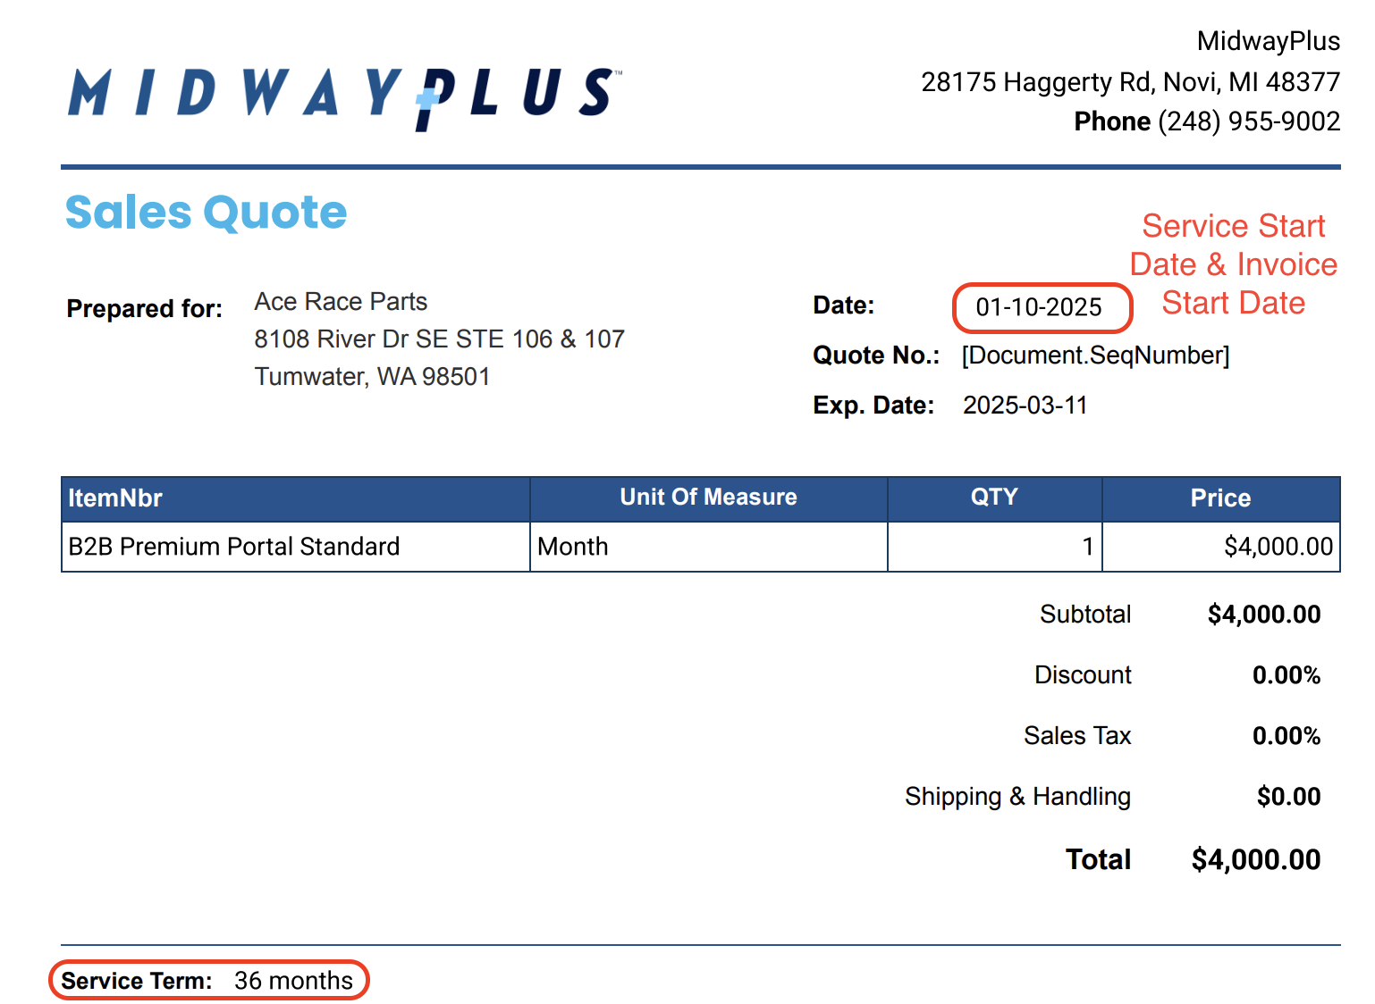

* 1. ItemNbr used for item name and unit of measure used for billing frequency
  2. See [Ace Race Parts](https://garage.tabsplatform.com/prod/contracts/ce2979f8-7765-4089-8f5d-6dbcbd21b801/terms/revenue) for example

1. Anything to ignore in contracts?
   1. N/A
2. Specifics processing things the merchant has requested that may differ by contract (e.g. always back-date invoice date to final day of the month)
   1. N/A
3. Default Service Term
   1. Found in “Service Term” at bottom of contract
4. Default Net Payment Terms
   1. 30
5. Default Billing Frequency
   1. Found in “Unit of Measure” in contract
6. How do we handle taxes as a line item?
   1. N/A

### Events Processing (if necessary) *(Implementation/Success to fill)*

* Any important information on events billing
  + N/A

Integration Items Processing (if necessary)  
*(Implementation/Success to fill)*

* What are the instructions for assigning integration items?

[MidwayPlus | Integration Items](https://docs.google.com/spreadsheets/d/1GfryAPUi7tWwmK6gXRdplxNdXzLQ9uUWB55-b42SV5U/edit?gid=0#gid=0)

Post Processing Communications (if necessary)  
*(Implementation/Success to fill)*

* Does the Ops Team need to notify anyone on the team re: completion of processing batches in Implementation or Active phase?
* Who needs to be notified and when?
  + Let Jeff know in #midwayplus channel

### Customer Information *(Implementation/Success to fill)*

* Any important information on specifics customers of this merchant
  + Special memo’s certain invoices require
  + Invoice changes due to merchant/customer relationship

### Feature Requests *(AE/Implementation/Success to fill)*

* FR 1
  + What is it
  + Why it's important
  + Urgency

### Rewatch Calls *(AE/Implementation/Success to fill)*

* <https://tabs.rewatch.com/video/mbbkgnke3q3pijca-greg-benjamin-meeting-november-4-2024>
* <https://tabs.rewatch.com/video/wbs7x3u3h9ps58oy-tabs-midway-plus-custom-demo-november-20-2024>